Motto: “Every action needs to be prompted by a motive”,
Leonardo Da Vinci, Notebooks

Exploring the Renaissance Genius: Leonardo da Vinci
A CLIL 3-WEEK PROJECT

Teacher: JALBA MARCELA

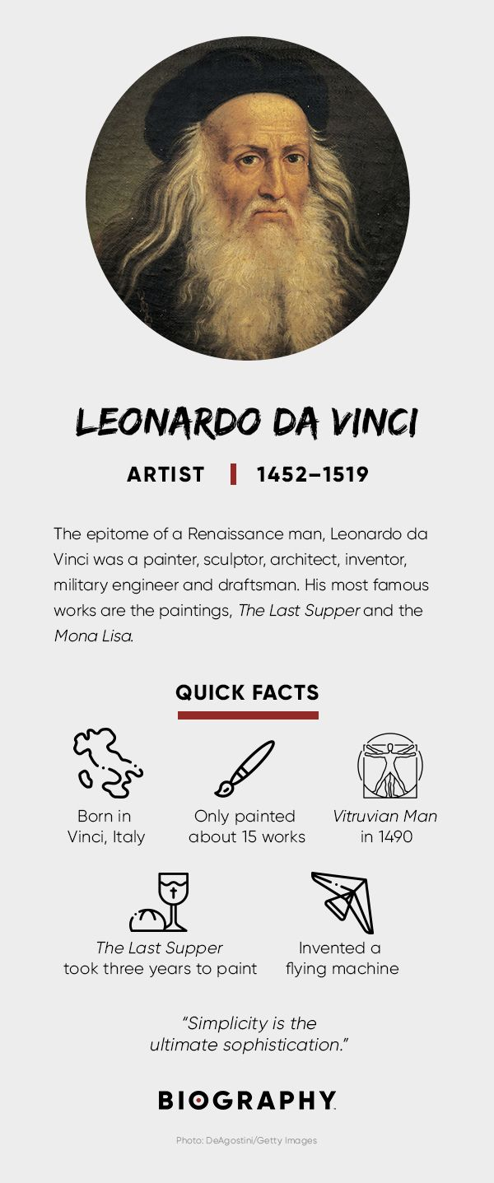

Upper-intermediate level/Advanced – B2+/C1
Aims:
- To familiarize ESL learners with the life and achievements of Leonardo da Vinci.
- To enhance English language skills, including reading, listening, speaking, and writing, through engaging activities and discussions.
- To develop critical thinking and research skills by analyzing and interpreting da Vinci's works.
- To promote cultural awareness and appreciation of art and science.
Resources:
- Biographical materials on Leonardo da Vinci (books, articles, websites, documentaries).
- Reproductions of da Vinci's artwork (printouts or digital images).
- Audio/video clips about da Vinci's life, inventions, and artistic techniques.
- Worksheets and handouts (see below).
- Art supplies (optional) for hands-on activities.
Competences to Achieve:
- Reading comprehension: Extracting key information from texts about Leonardo da Vinci's life and works.
- Listening skills: Understanding and summarizing audio/video clips related to da Vinci.
- Speaking skills: Engaging in discussions and presentations about da Vinci's contributions.
- Writing skills: Expressing opinions, analyzing artwork, and composing short essays on da Vinci.
- Critical thinking: Analyzing and interpreting da Vinci's art, inventions, and scientific ideas.
- Research skills: Conducting independent research on specific aspects of da Vinci's life or works.
Week 1: Introducing Leonardo da Vinci Objective:
To familiarize ESL learners with the life, achievements, and significance of Leonardo da Vinci.
Activities:

1. Introduction to Leonardo da Vinci (Worksheet - QUICK FACTS)
  - Present a brief biography of da Vinci, highlighting his major works and contributions.
  - Discuss the historical and cultural context of the Renaissance period.
- Vocabulary Building (See Vocabulary worksheet)
  - Introduce da Vinci-related vocabulary words (e.g., polymath, sfumato, anatomical studies) and their definitions.
  - Engage students in vocabulary exercises, such as matching definitions, completing sentences, or creating word associations.
- Da Vinci's Artwork Exploration (See Worksheet 2)
  - Show reproductions of da Vinci's iconic artworks.
  - Guide students in analyzing and discussing the artistic techniques, themes, and symbolism in his paintings.
  - Encourage students to express their opinions and interpretations.
- Group Discussion: Leonardo's Impact
  - Divide students into groups and assign different areas of da Vinci's expertise (art, science, engineering, etc.).
  - Have each group discuss and present on how da Vinci's contributions influenced those fields.
Week 2: Delving into Da Vinci's Inventions Objective: To explore Leonardo da Vinci's engineering and scientific inventions.
Activities:
- Invention Showcase
  - Introduce some of da Vinci's notable inventions, such as the flying machine, parachute, or self-propelled cart.
  - Display images or models of these inventions and facilitate a class discussion about their functions and potential applications.
- Inventor's Workshop
  - Divide students into small groups and assign each group one of da Vinci's inventions to research.
  - Encourage them to investigate the design principles, challenges, and potential impacts of the assigned invention.
  - Have groups present their findings, promoting discussion and critical thinking.
- Hands-On Activity: Engineering Challenge – optional, if possible
  - Organize a hands-on activity where students are tasked with designing and building a model inspired by one of da Vinci's inventions.
  - Provide materials and guidelines to ensure creativity, problem-solving, and collaboration.
  - Students present their models, explaining the engineering concepts and design choices behind them.
Week 3: Da Vinci's Legacy and Beyond Objective: To reflect on the enduring influence and relevance of Leonardo da Vinci's work and ideas.
Activities:
- Research Project: Contemporary Innovators
  - Assign students to research modern-day innovators who have been influenced by da Vinci's multidisciplinary approach.
  - Encourage students to explore scientists, artists, or engineers who embody da Vinci's spirit of curiosity and innovation.
  - Students present their findings, emphasizing the connections between da Vinci's legacy and contemporary thinkers.
- Creative Expression: Inspired Artwork
  - Encourage students to create their own artwork inspired by da Vinci's style, themes, or techniques.
  - Bring art supplies to class and provide guidance for students to experiment with techniques like sfumato or chiaroscuro.
  - Allow students to share and discuss their artworks, fostering appreciation for each other's creativity.
- Culminating Discussion: Da Vinci's Impact Today (See Worksheet)
  - Facilitate a class discussion on the relevance of da Vinci's ideas in the present day.
  - Encourage students to reflect on how da Vinci's interdisciplinary mindset and pursuit of knowledge can inspire innovation and problem-solving in their own lives.
Note: Students will pick the first or the second activity to carry out, according to their abilities/skills/preferences. The third activity is a summary of the project.

1 Worksheet - QUICK FACTS
- Name: Leonardo da Vinci
- Birth Year: 1452
- Birth date: April 15, 1452
- Birth City: Vinci
- Birth Country: Italy
- Gender: Male
- Best Known For: Leonardo da Vinci was a Renaissance artist and engineer, known for paintings like "The Last Supper" and "Mona Lisa,” and for inventions like a flying machine.
- Industries
  - Art
  - Science and Medicine
  - Writing and Publishing
  - Architecture
  - Technology and Engineering
- Astrological Sign: Aries
- Nationality
  - Italian
- Interesting Facts
  - Leonardo da Vinci was born out of wedlock to a respected Florentine notary and a young peasant woman.
  - Da Vinci used tempera and oil on dried plaster to paint "The Last Supper," which led to its quick deterioration and flaking.
  - For da Vinci, the "Mona Lisa" was forever a work in progress, as it was his attempt at perfection, and he never parted with the painting.
- Death Year: 1519
- Death date: May 2, 1519
- Death City: Amboise
- Death Country: France

2 Vocabulary worksheet
Instructions: Match the da Vinci-related vocabulary words with their corresponding definitions on the right.
Vocabulary Words:
- Polymath
- Sfumato
- Anatomy
- Renaissance
- Inventor
- Chiaroscuro
- Engineering
- Scientific
- Innovator
- Curiosity
Definitions:
a. The blending of colours to create a soft, hazy effect in painting.
b. The study of the structure and parts of the human body.
c. A person who has expertise and knowledge in multiple fields.
d. A period of great cultural and artistic rebirth in Europe from the 14th to the 17th century.
e. A person who designs and creates new devices or solutions.
f. The balance and contrast between light and shadow in a work of art.
g. The application of scientific knowledge to practical purposes, such as building or inventing.
h. Pertaining to or based on scientific principles or methods.
i. Someone who introduces new ideas, methods, or products.
j. A strong desire to learn or know more about something.
Answer Key:
- Polymath - c. A person who has expertise and knowledge in multiple fields.
- Sfumato - a. The blending of colours to create a soft, hazy effect in painting.
- Anatomy - b. The study of the structure and parts of the human body.
- Renaissance - d. A period of great cultural and artistic rebirth in Europe from the 14th to the 17th century.
- Inventor - e. A person who designs and creates new devices or solutions.
- Chiaroscuro - f. The balance and contrast between light and shadow in a work of art.
- Engineering - g. The application of scientific knowledge to practical purposes, such as building or inventing.
- Scientific - h. Pertaining to or based on scientific principles or methods.
- Innovator - i. Someone who introduces new ideas, methods, or products.
- Curiosity - j. A strong desire to learn or know more about something.

3 Worksheet: Analyzing and Discussing Artistic Techniques, Themes, and Symbolism in da Vinci's Paintings
“The Annunciation”
- Describe the use of colours in the painting and their symbolism.
- Analyze the positioning and gestures of the figures. What message do they convey?
- Discuss the role of the angel's wings in representing spirituality and divine intervention.
- How does the architectural setting contribute to the overall composition and atmosphere?
- Identify any hidden or subtle details in the painting that add depth or symbolism.
https://artsandculture.google.com/asset/annunciation/sAErNLFH1KFYmw?hl=ro

4 Worksheet: Da Vinci's Impact Today
Discussion Questions:
- How has da Vinci's approach to interdisciplinary learning influenced modern education or research?
- Can you identify any examples of contemporary art that display elements or techniques inspired by da Vinci's paintings?
- In what ways have da Vinci's anatomical studies influenced medical science and advancements in healthcare?
- Are there any engineering marvels or technological innovations today that can be traced back to da Vinci's engineering concepts?
- How does da Vinci's emphasis on observation and curiosity resonate with the scientific method and modern scientific inquiry?
- Can you think of any contemporary figures who embody da Vinci's spirit of creativity, curiosity, and innovation?
- Do you believe da Vinci's work and ideas will continue to shape future generations? Why or why not?
- Group Presentations
- Ask each group to select one or two discussion questions and prepare a brief presentation summarizing their findings and opinions.
- Encourage students to use visual aids, such as images or slides, to enhance their presentations.
- Allocate time for questions and open discussion after each group's presentation.
- Whole Class Discussion:
- Facilitate a whole class discussion, allowing students to share their key insights, thoughts, and observations.
- Encourage respectful debate and the exchange of different perspectives.
- Summarize the main points discussed and highlight the continued relevance and impact of da Vinci's work.

Resources:
- Anderson, Maxine, Amazing Leonardo Inventions You can build Yourself, Nomad Press, 2006
- Isaacson, Walter, "Leonardo da Vinci", Simon & Schuster, 2017
- Vezzosi, Alessandro, "Leonardo da Vinci: The Complete Paintings and Drawings", Harry N. Abrams, 2017
- Zöllner, Frank, "Leonardo da Vinci: The Complete Paintings and Drawings", Taschen, 2015
- Veltman, Kim, "Leonardo da Vinci: Artist, Scientist, Inventor", Sterling, 2006
- The official website of the Leonardo da Vinci Museum: https://www.leonardodavincimuseo.com/en/
- https://www.leonardo-da-vinci.net/inventions/
- https://vk.com/@new_forwardls_ru-why-leonardo-da-vincis-brilliance-endures-500-years-after-hi
- https://www.biography.com/artists/leonardo-da-vinci
- https://www.mos.org/leonardo/biography

